# Learner Details

Total Study Time:

2:27:59

[18dce136@charusat.edu.in](mailto:18dce136@charusat.edu.in)

E-mail:

Name:

Mihir Vaishnav

Certified Courses

India

Country:

Job Search Skills - Preparing Your Resume and Cover Letter - Revised

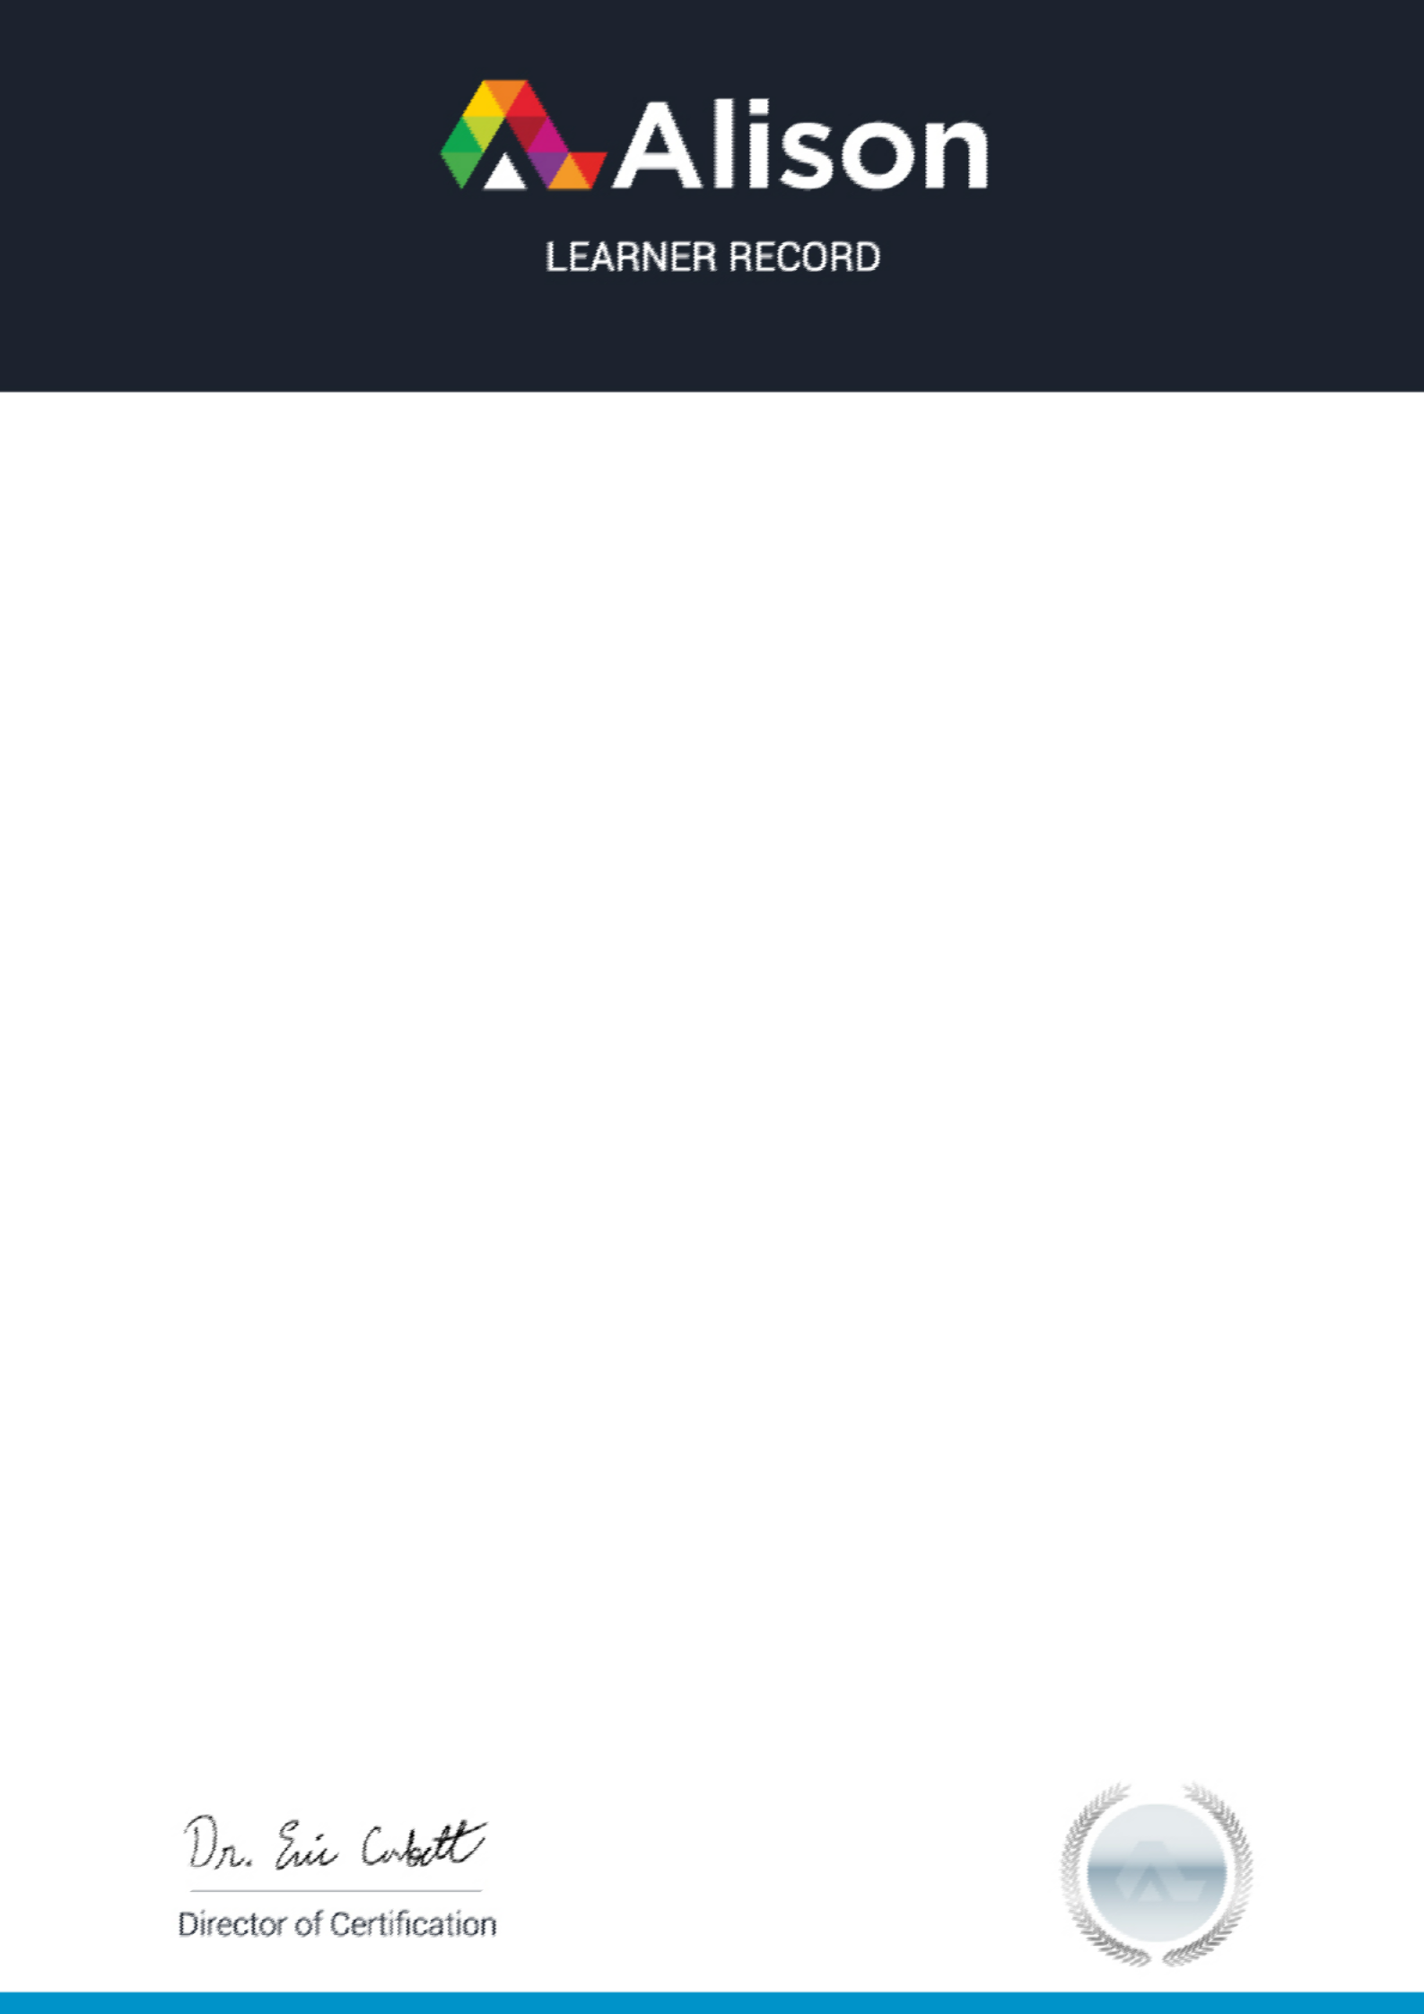

## Score

88%

Completed On

2020-09-09

The course first breaks down the job application process, so you can ensure that you identify and apply for the right job. It then goes through the essential elements of a resume showing you how to design a professional header and layout, write a concise outline of your background, and format your resume differently depending on what kind of job you are applying for. The course then goes through cover letter planning and design, before giving you examples for you to work with.